MODULE 1
Analysis of Species-wise Bird Migration Behaviour
Data Warehouse Design -Star Schema
Objective:
The objective of this study is to analyse the bird migration patterns recorded in the Bird_Migration_Data_with_Origin dataset in order to identify species-wise migration behavior, frequently visited destinations, and commonly used migration routes. The study aims to examine how attributes such as bird species, origin location, destination location, migration distance, season, and time period influence the overall success or failure of migration events captured in the dataset. It seeks to identify major geographic regions that act as migration hubs and to evaluate origin–destination routes based on their frequency and success rates. The analysis also focuses on understanding seasonal and temporal trends present in the dataset by observing variations in migration activity across months, seasons, and years. Additionally, the study aims to assess route resilience by identifying migration paths that consistently show successful outcomes over time. Species-level analysis is conducted to determine adaptability, consistency, and challenges faced during migration based on the recorded data attributes. Overall, the objective is to derive meaningful insights from the dataset that explain migration success patterns, failure reasons, and long-term trends, thereby supporting data-driven understanding of bird migration behavior.
Migration Dataset:
The dataset titled Bird_Migration contains structured records of bird migration events collected across different geographic regions and time periods. Each record in the dataset represents an individual migration observation and includes information related to the bird species involved, the origin and destination locations, and the migration route followed. Geographic attributes such as country, region, and continent help in analyzing spatial migration patterns and identifying major migration hubs. Temporal attributes including year, month, and season enable the study of seasonal and long-term migration trends. The dataset also includes migration-related measures such as migration distance, migration outcome (success or failure), and, where applicable, reasons for migration failure. These attributes allow for detailed analysis of migration efficiency, route resilience, and species adaptability. Overall, the dataset supports comprehensive analysis of bird migration behavior by combining species, geographic, temporal, and outcome-based information, making it suitable for exploratory data analysis, data warehousing design, and visualization-based insights.
Dataset Description:
Source:Kaggle
Link: https://www.kaggle.com/datasets/sahirmaharajj/bird-migration-dataset-data-visualization-eda
Number of columns:43
Number of rows:10000
Size: 3.2 MB

Feature type Identification:

Column Name |  | Data Type
Bird_ID | Categorical
Bird_Name | Categorical
Species | Categorical
Region | Categorical
Habitat | Categorical
Weather_Condition | Categorical
Migration_Reason | Categorical
Start_Latitude | Numerical
Start_Longitude | Numerical
End_Latitude | Numerical
End_Longitude | Numerical
Flight_Distance_km | Numerical
Flight_Duration_hours | Numerical
Average_Speed_kmph | Numerical
Max_Altitude_m | Numerical
Min_Altitude_m | Numerical
Temperature_C | Numerical
Wind_Speed_kmph | Numerical
Humidity_% | Numerical
Pressure_hPa | Numerical
Visibility_km | Numerical
Nesting_Success | Categorical
Tag_Battery_Level_% | Numerical
Signal_Strength_dB | Numerical
Migration_Start_Month | Categorical
Migration_End_Month | Categorical
Rest_Stops | Numerical
Predator_Sightings | Numerical
Tag_Type | Categorical
Migrated_in_Flock | Categorical
Flock_Size | Numerical
Food_Supply_Level | Categorical
Tracking_Quality | Categorical
Migration_Interrupted | Categorical
Interrupted_Reason | Categorical
Tagged_By | Categorical
Tag_Weight_g | Numerical
Migration_Success | Categorical
Recovery_Location_Known | Categorical
Recovery_Time_days | Numerical
Observation_Counts | Numerical
Observation_Quality | Categorical
Origin | Categorical

Milestone (Questions):
- Which destinations are most frequently used by each bird species, and what common factors explain these preferences?
- What are the primary reasons behind successful bird migrations across different species?
- What factors most often lead to migration failure among birds?
- How does migration distance influence the success rate of bird migrations?
- Which bird species show the most consistent migration routes over time?
- Which regions act as major migration hubs for multiple bird species?
- What migration routes experience the highest success rates?
- Which origin–destination routes are most prone to migration failures?
- How do geographic characteristics influence bird migration outcomes?
- Which locations function as both major origin and destination points in migration patterns?
- How do migration success rates vary across seasons?
- Which time periods show peak migration activity and why?
- How have bird migration patterns changed over the years?
- During which months do migration failures occur most frequently?
- What long-term trends exist in migration distance and frequency?
- Which bird species demonstrate the highest adaptability in their migration behavior?
- How do environmental conditions impact migration success across species?
- What patterns distinguish short-distance migrations from long-distance migrations?
- What common characteristics are observed in resilient migration routes?
- Which species face the greatest migration challenges, and what factors contribute to these difficulties?

Dataset Preprocessing:
First 5 rows:
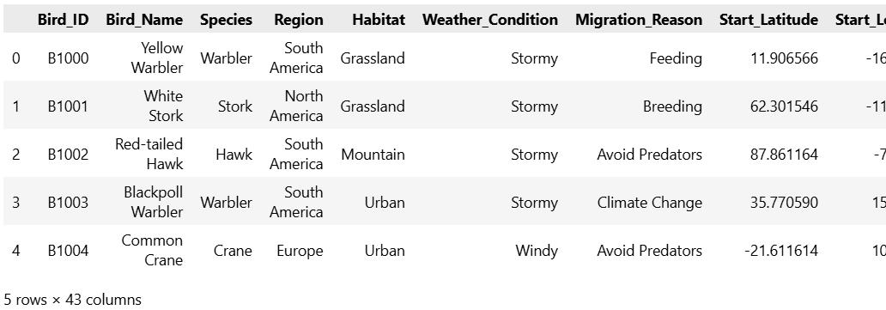
Describing the data set:
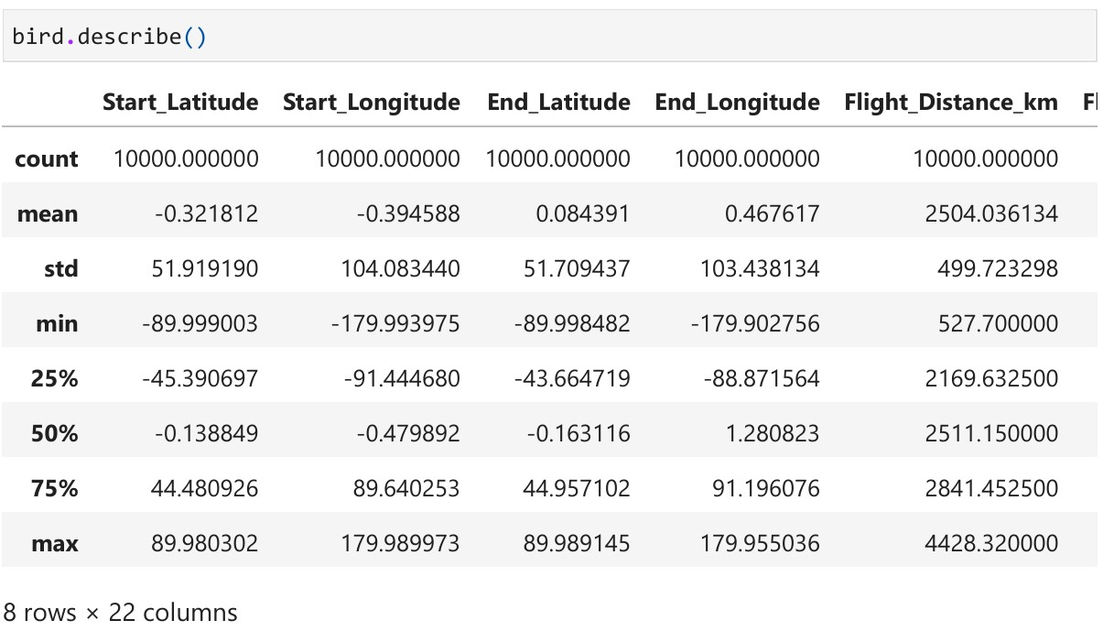

Attributes and its type:
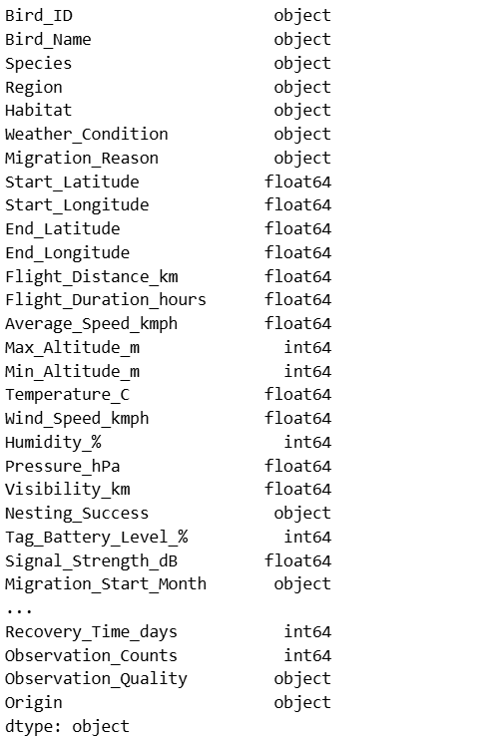

Handling null values:
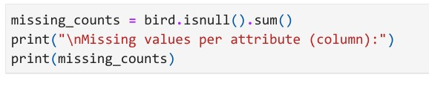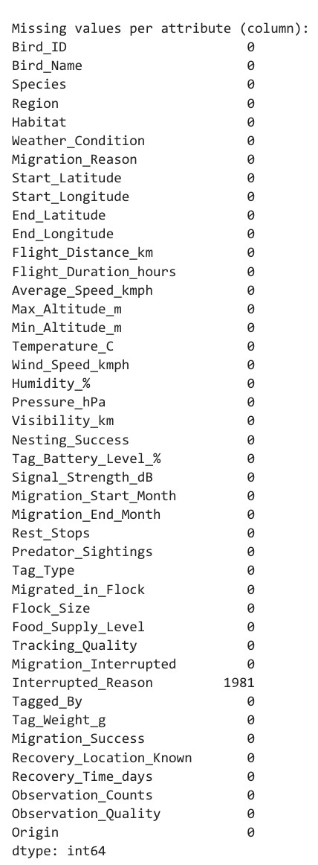

After Filling null Values with ffill:
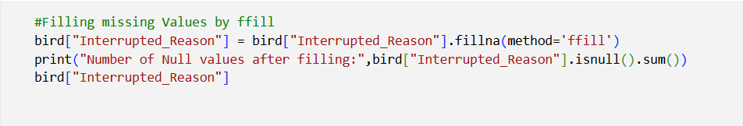
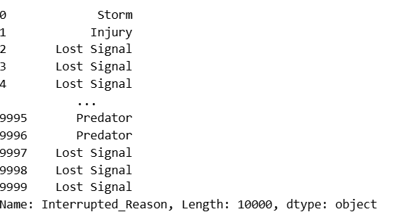

Encodings:
Label Encoding:
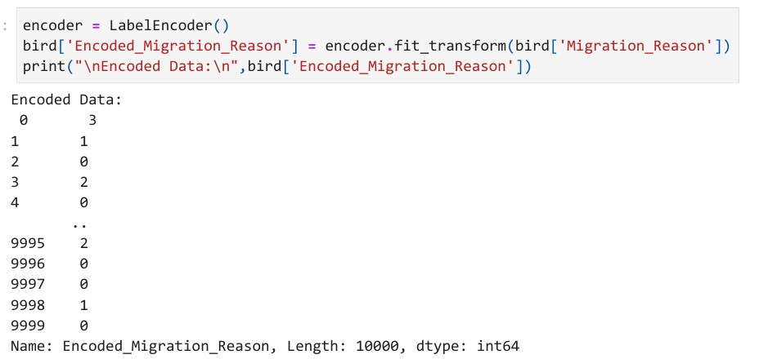

One hot Encoding:
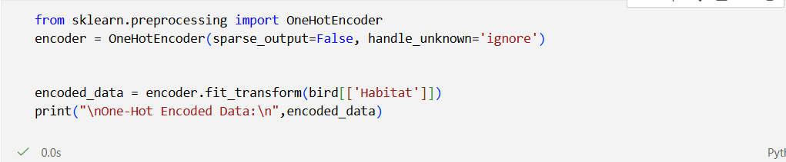
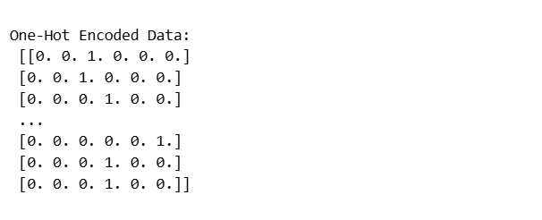

Box plot:
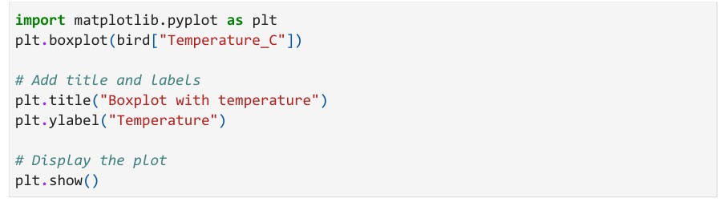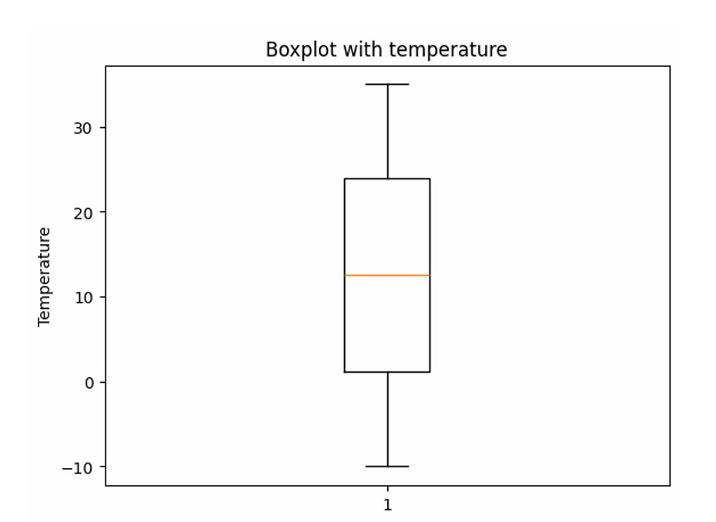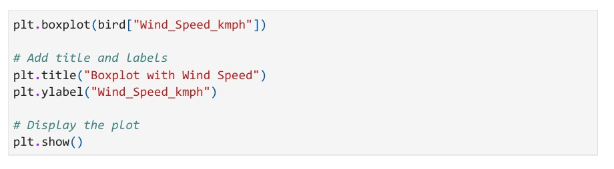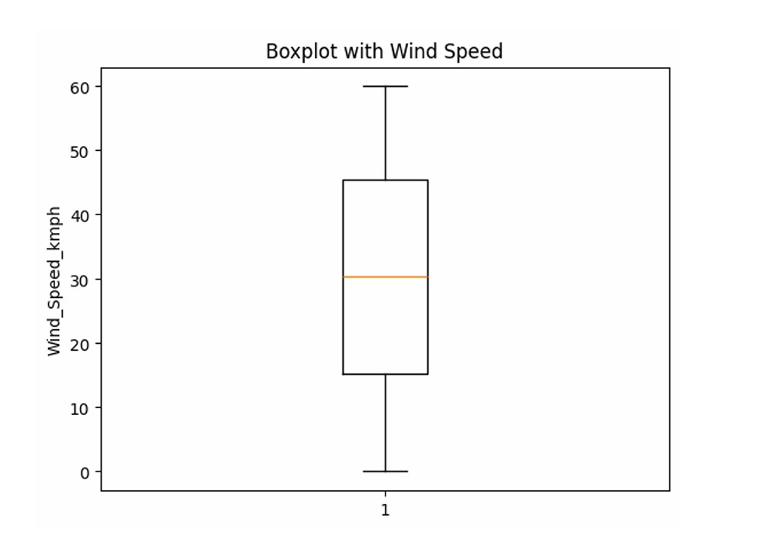

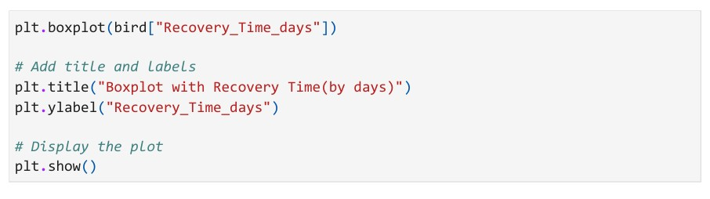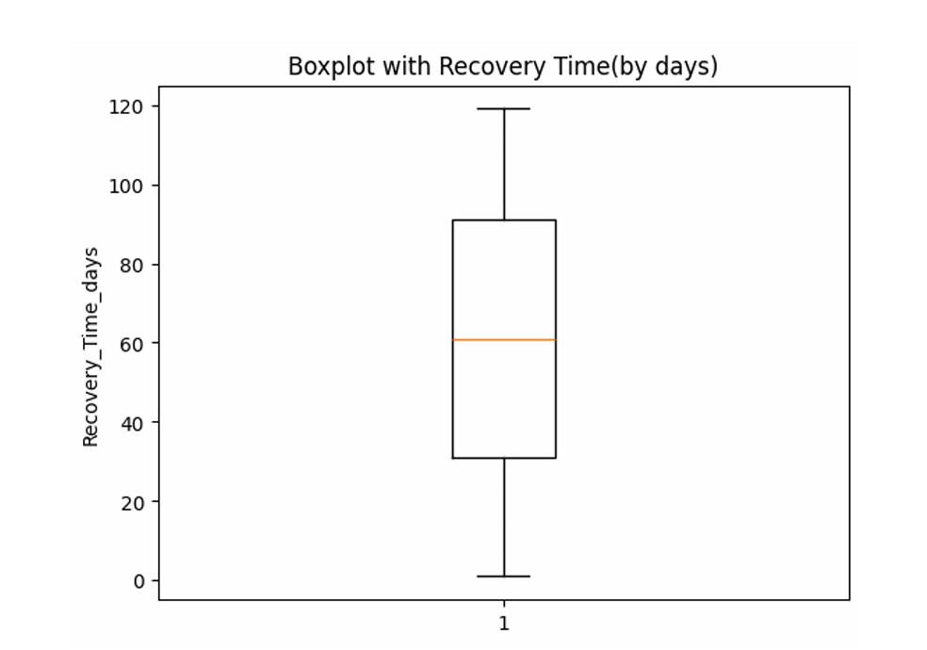

Fact and Dimension table:
Fact Table:
A fact table is used in the dimensional model in data warehouse design. A fact table is found at the center of a star schema or snowflake schema surrounded by dimension tables. A fact table consists of facts of a particular business process e.g., sales revenue by month by product. Facts are also known as measurements or metrics. A fact table record captures a measurement or a metric.
Dimension Table:
In data warehousing, a dimension table is one of the companion tables to a fact table in the star schema. Different from a fact table that contains measures or business facts, a dimension table contains the textual descriptor of the business. The fields of the dimension table are designed to satisfy these two important requirements: a. Query constraining / grouping / filtering.
b. Report labelling
Steps in Designing Fact Table:
There are 4 major steps involved in designing a fact table
- Choosing business process to a model –The first step is to decide what business process to model by gathering and understanding business needs and available data
- Declare the grain – by declaring a grain means describing exactly what a fact table record represents
- Choose the dimensions – once the grain of the fact table is stated clearly, it is time to determine dimensions for the fact table.
- Identify facts – identify carefully which facts will appear in the fact table.

Fact & Dimension Table :
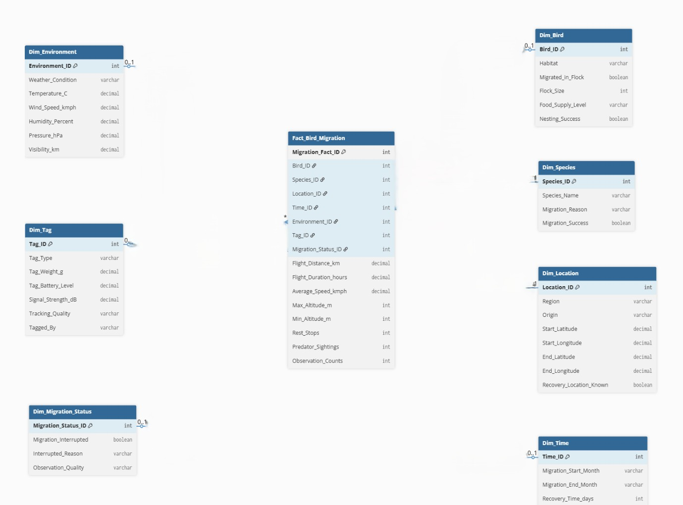Fig 1.1 Fact and Dimension table
Fact table:
Fact_Bird_Migration
Dimension table:
Dim_Environment
Dim_Tag
Dim_Migration_status
Dim_Time
Dim_Location
Dim_species
Dim_Bird
Star Schema:
Star schema is a dimensional design for a relational database often used in a data warehouse system. The star schema has a fact table at the center, and some dimension tables surround the fact table. The star schema name comes from the appearance of the schema, which looks like a star. In the star schema, related dimensions are grouped as columns in dimension tables and used to store the context of the facts stored in the fact table.
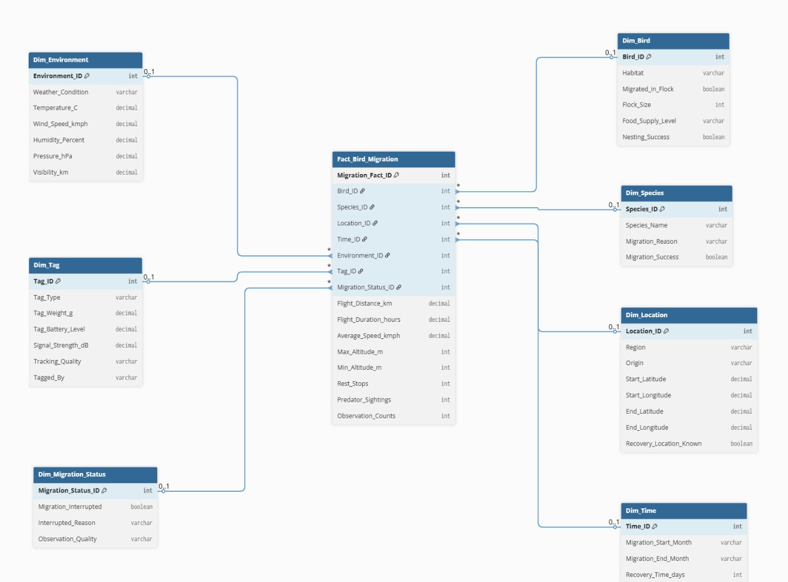Fig 1.2 Star Schema

Star schema description:
Fact_Bird_Migration is a fact table having attributes i.e.
(Bird_ID,Species_ID,Location_ID,Time_ID,Environment_ID, Tag_ID, Migration_Status_ID, Flight_Distance_km, Flight_Duration_hours, Average_Speed_kmph, Max_Altitude_m, Min_Altitude_m, Rest_Stops, Predator_Sightings, Observation_Counts) which references the dimension tables.

Bird dimension table contains the attributes:
Bird_ID, Habitat, Migrated_in_Flock, Flock_Size, Food_Supply_Level and Nesting_Success.

Species dimension table contains the attributes:
Species_ID, Species_Name, Migration_Reason and Migration_Success.

Location dimension table contains the attributes:
Location_ID, Region, Origin, Start_Latitude, Start_Longitude, End_Latitude, End_Longitude and Recovery_Location_Known
Time dimension table contains the attributes:
Time_ID, Migration_Start_Month, Migration_End_Month and Recovery_Time_days.

Environment dimension table contains the attributes:
Environment_ID,Weather_Condition,Temperature_C,Wind_Speed_kmph, Humidity_Percent, Pressure_hPa and Visibility_km.

Tag dimension table contains the attributes:
Tag_ID, Tag_Type, Tag_Weight_g, Tag_Battery_Level, Signal_Strength_dB, Tracking_Quality and Tagged_By.

Migration_Status dimension table contains the attributes:
Migration_Status_ID, Migration_Interrupted, Interrupted_Reason and Observation_Quality.

Snowflake Schema:
Snowflake schema consists of a fact table surrounded by multiple dimension tables which can be connected to other dimension tables via many-to-one relationship. The snowflake schema is a kind of star schema however it is more complex than a star schema in terms of the data model. This schema resembles a snowflake, therefore, it is called the snowflake schema. A snowflake schema is designed from the star schema by further normalizing dimension tables to eliminate data redundancy. Therefore, in the snowflake schema, instead of having big dimension tables connected to a fact table, we have a group of multiple dimension tables. In the snowflake schema, dimension tables are normally in the third normal form (3NF). The snowflake schema helps save storage however it increases the number of dimension tables.

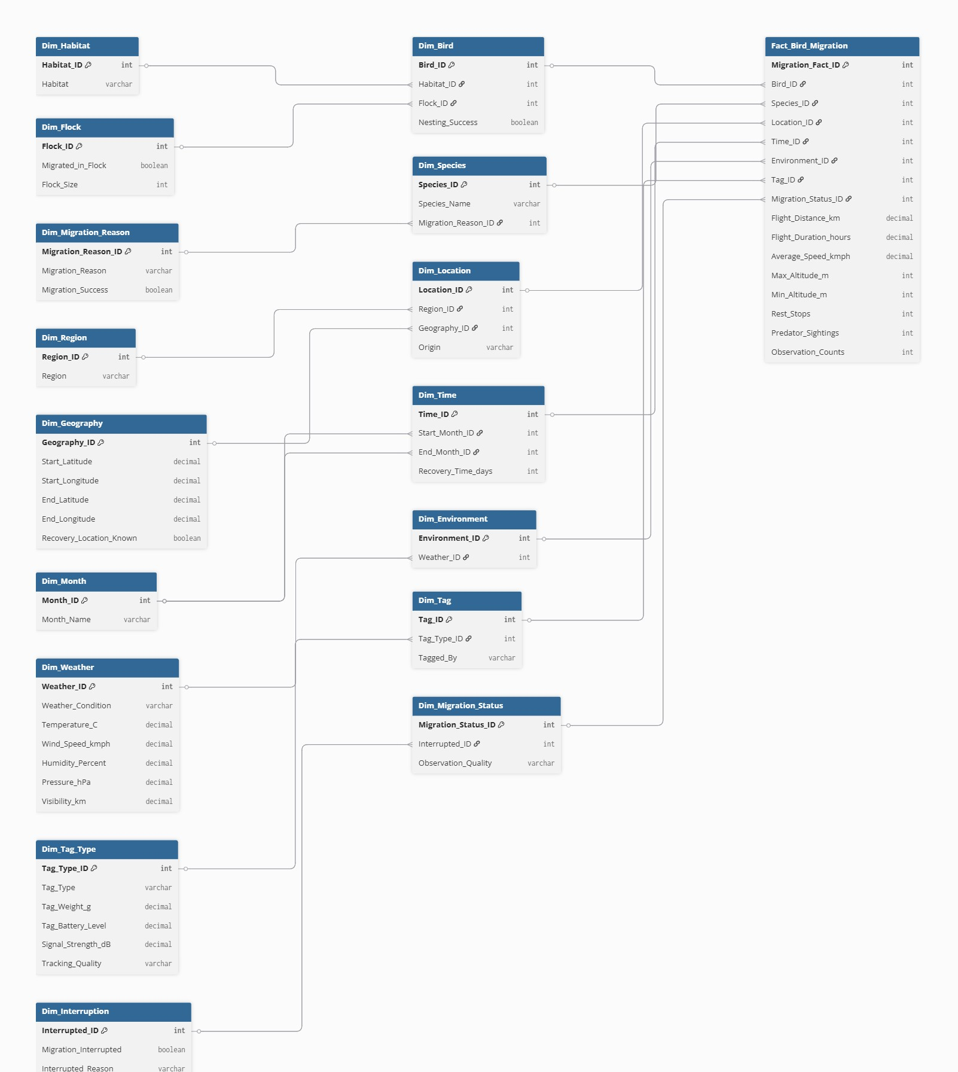
Fig 1.3 Snowflake Schema
Snowflake Schema Description:
Fact_Bird_Migration
Migration_Fact_ID (PK), Bird_ID (FK), Species_ID (FK), Location_ID (FK), Time_ID (FK), Environment_ID (FK), Tag_ID (FK), Migration_Status_ID (FK), Flight_Distance_km, Flight_Duration_hours,
Average_Speed_kmph, Max_Altitude_m, Min_Altitude_m, Rest_Stops, Predator_Sightings, Observation_Counts
Dim_Bird
Bird_ID (PK), Habitat_ID (FK), Flock_ID (FK), Nesting_Success
Dim_Habitat
Habitat_ID (PK), Habitat
Dim_Flock
Flock_ID (PK), Migrated_in_Flock, Flock_Size
Dim_Species
Species_ID (PK), Species_Name, Migration_Reason_ID (FK)
Dim_Migration_Reason
Migration_Reason_ID (PK), Migration_Reason, Migration_Success
Dim_Location
Location_ID (PK), Region_ID (FK), Geography_ID (FK), Origin
Dim_Region
Region_ID (PK), Region Dim_Geography
Geography_ID (PK), Start_Latitude, Start_Longitude, End_Latitude, End_Longitude, Recovery_Location_Known
Dim_Time
Time_ID (PK), Start_Month_ID (FK), End_Month_ID (FK), Recovery_Time_days
Dim_Month
Month_ID (PK), Month_Name
Dim_Environment
Environment_ID (PK), Weather_ID (FK)
Dim_Weather
Weather_ID (PK), Weather_Condition, Temperature_C, Wind_Speed_kmph, Humidity_Percent, Pressure_hPa, Visibility_km
Dim_Tag
Tag_ID (PK), Tag_Type_ID (FK), Tagged_By
Dim_Tag_Type
Tag_Type_ID (PK), Tag_Type, Tag_Weight_g, Tag_Battery_Level, Signal_Strength_dB, Tracking_Quality Dim_Migration_Status
Migration_Status_ID (PK), Interrupted_ID (FK), Observation_Quality
Dim_Interruption
Interrupted_ID (PK), Migration_Interrupted, Interrupted_Reason

Problem Statement:

Statement 1:
A wildlife research organization is conducting a large-scale study on bird migration patterns across different regions and seasons. The organization collects data related to individual birds, species, migration routes, environmental conditions, tracking tags, and migration status. Due to the large volume of data generated from continuous observations and tracking devices, the organization requires an efficient data warehousing solution to support analysis and decision-making.The objective is to identify suitable fact and dimension tables that will enable the organization to analyze migration distance, duration, speed, environmental impact, and migration success using PostgreSQL.

Result:
Thus, the graphs for Star schema and Snowflake schema generated using PostgreSQL.

